Apache Solr - Indexing Data

In general, **indexing** is an arrangement of documents or (other entities) systematically. Indexing enables users to locate information in a document.

* Indexing collects, parses, and stores documents.
* Indexing is done to increase the speed and performance of a search query while finding a required document.

Indexing in Apache Solr

In Apache Solr, we can index (add, delete, modify) various document formats such as xml, csv, pdf, etc. We can add data to Solr index in several ways.

In this chapter, we are going to discuss indexing −

* Using the Solr Web Interface.
* Using any of the client APIs like Java, Python, etc.
* Using the **post tool**.

In this chapter, we will discuss how to add data to the index of Apache Solr using various interfaces (command line, web interface, and Java client API)

Adding Documents using Post Command

Solr has a **post** command in its **bin/** directory. Using this command, you can index various formats of files such as JSON, XML, CSV in Apache Solr.

Browse through the **bin** directory of Apache Solr and execute the **–h option** of the post command, as shown in the following code block.

[Hadoop@localhost bin]$ cd $SOLR_HOME

[Hadoop@localhost bin]$ post -h

On executing the above command, you will get a list of options of the **post command**, as shown below.

Usage: post -c <collection> [OPTIONS] <files|directories|urls|-d [".."]>

or post –help

collection name defaults to DEFAULT_SOLR_COLLECTION if not specified

OPTIONS

=======

Solr options:

-url <base Solr update URL> (overrides collection, host, and port)

-host <host> (default: localhost)

-p or -port <port> (default: 8983)

-commit yes|no (default: yes)

Web crawl options:

-recursive <depth> (default: 1)

-delay <seconds> (default: 10)

Directory crawl options:

-delay <seconds> (default: 0)

stdin/args options:

-type <content/type> (default: application/xml)

Other options:

-filetypes <type>[,<type>,...] (default:

xml,json,jsonl,csv,pdf,doc,docx,ppt,pptx,xls,xlsx,odt,odp,ods,ott,otp,ots,

rtf,htm,html,txt,log)

-params "<key> = <value>[&<key> = <value>...]" (values must be

URL-encoded; these pass through to Solr update request)

-out yes|no (default: no; yes outputs Solr response to console)

-format Solr (sends application/json content as Solr commands

to /update instead of /update/json/docs)

Examples:

* JSON file:post -c wizbang events.json

* XML files: post -c records article*.xml

* CSV file: post -c signals LATEST-signals.csv

* Directory of files: post -c myfiles ~/Documents

* Web crawl: post -c gettingstarted http://lucene.apache.org/Solr -recursive 1 -delay 1

* Standard input (stdin): echo '{commit: {}}' | post -c my_collection -

type application/json -out yes –d

|  |  |  |  |  |
| --- | --- | --- | --- | --- |
| **Student ID** | **First Name** | **Lasst Name** | **Phone** | **City** |
| 001 | Rajiv | Reddy | 9848022337 | Hyderabad |
| 002 | Siddharth | Bhattacharya | 9848022338 | Kolkata |
| 003 | Rajesh | Khanna | 9848022339 | Delhi |
| 004 | Preethi | Agarwal | 9848022330 | Pune |
| 005 | Trupthi | Mohanty | 9848022336 | Bhubaneshwar |
| 006 | Archana | Mishra | 9848022335 | Chennai |

* Data as string: post -c signals -type text/csv -out yes -d $'id,value\n1,0.47'

Example

Suppose we have a file named **sample.csv** with the following content (in the **bin** directory).

The above dataset contains personal details like Student id, first name, last name, phone, and city. The CSV file of the dataset is shown below. Here, you must note that you need to mention the schema, documenting its first line.

id, first_name, last_name, phone_no, location

001, Pruthvi, Reddy, 9848022337, Hyderabad

002, kasyap, Sastry, 9848022338, Vishakapatnam

003, Rajesh, Khanna, 9848022339, Delhi

004, Preethi, Agarwal, 9848022330, Pune

005, Trupthi, Mohanty, 9848022336, Bhubaneshwar

006, Archana, Mishra, 9848022335, Chennai

You can index this data under the core named **sample_Solr** using the **post** command as follows −

[Hadoop@localhost bin]$ post -c Solr_sample sample.csv

On executing the above command, the given document is indexed under the specified core, generating the following output.

/home/Hadoop/java/bin/java -classpath /home/Hadoop/Solr/dist/Solr-core

6.2.0.jar -Dauto = yes -Dc = Solr_sample -Ddata = files

org.apache.Solr.util.SimplePostTool sample.csv

SimplePostTool version 5.0.0

Posting files to [base] url http://localhost:8983/Solr/Solr_sample/update...

Entering auto mode. File endings considered are

xml,json,jsonl,csv,pdf,doc,docx,ppt,pptx,xls,xlsx,odt,odp,ods,ott,otp,ots,rtf,

htm,html,txt,log

POSTing file sample.csv (text/csv) to [base]

1 files indexed.

COMMITting Solr index changes to

http://localhost:8983/Solr/Solr_sample/update...

Time spent: 0:00:00.228

Visit the homepage of Solr Web UI using the following URL −

**http://localhost:8983/**

Select the core **Solr_sample**. By default, the request handler is **/select** and the query is “:”. Without doing any modifications, click the **ExecuteQuery** button at the bottom of the page.

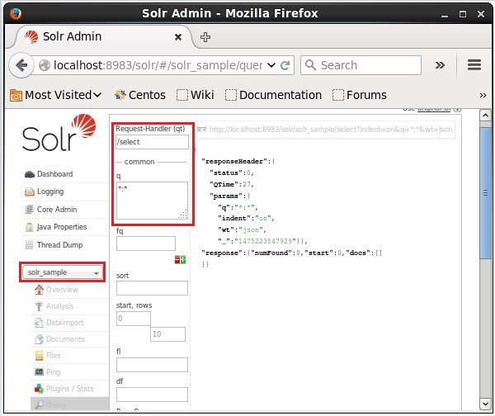

On executing the query, you can observe the contents of the indexed CSV document in JSON format (default), as shown in the following screenshot.

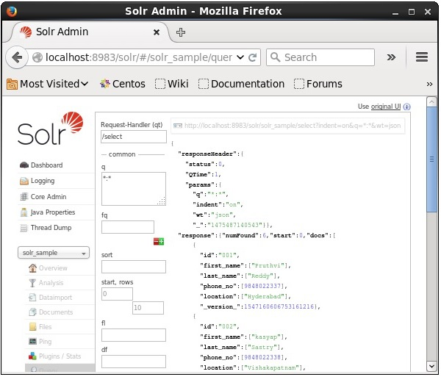

**Note** − In the same way, you can index other file formats such as JSON, XML, CSV, etc.

Adding Documents using the Solr Web Interface

You can also index documents using the web interface provided by Solr. Let us see how to index the following JSON document.

[

{

"id" : "001",

"name" : "Ram",

"age" : 53,

"Designation" : "Manager",

"Location" : "Hyderabad",

},

{

"id" : "002",

"name" : "Robert",

"age" : 43,

"Designation" : "SR.Programmer",

"Location" : "Chennai",

},

{

"id" : "003",

"name" : "Rahim",

"age" : 25,

"Designation" : "JR.Programmer",

"Location" : "Delhi",

}

]

Step 1

Open Solr web interface using the following URL −

**http://localhost:8983/**

**Step 2**

Select the core **Solr_sample**. By default, the values of the fields Request Handler, Common Within, Overwrite, and Boost are /update, 1000, true, and 1.0 respectively, as shown in the following screenshot.

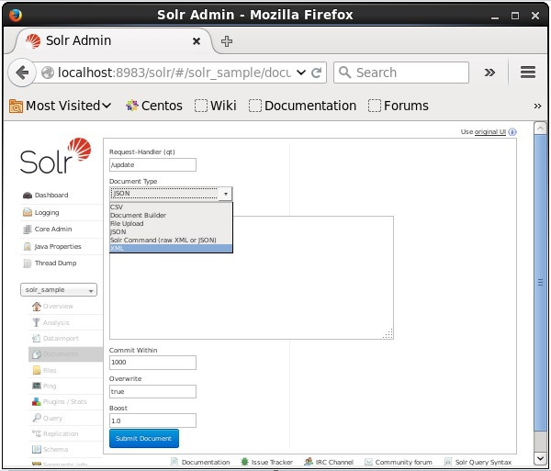

Now, choose the document format you want from JSON, CSV, XML, etc. Type the document to be indexed in the text area and click the **Submit Document** button, as shown in the following screenshot.

